Task4:

1.Creating VM Scale Set,

2.Recovery & backup of VM

3.VM disk encryption

* Created Resource Group with name SaravananRG

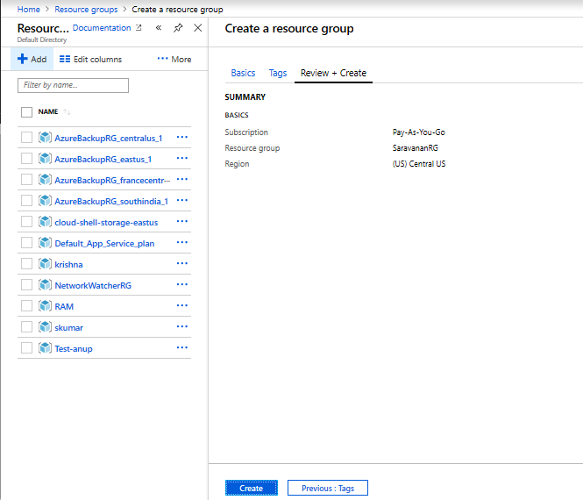

* Steps to Created Virtual Machine Scale Set Process

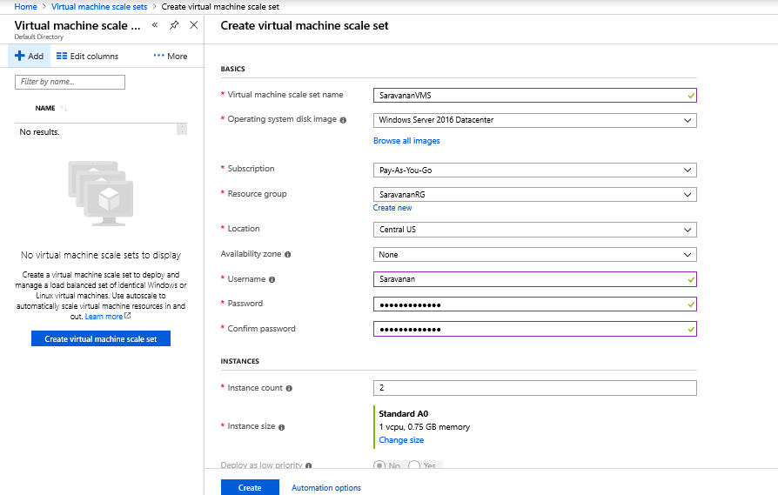

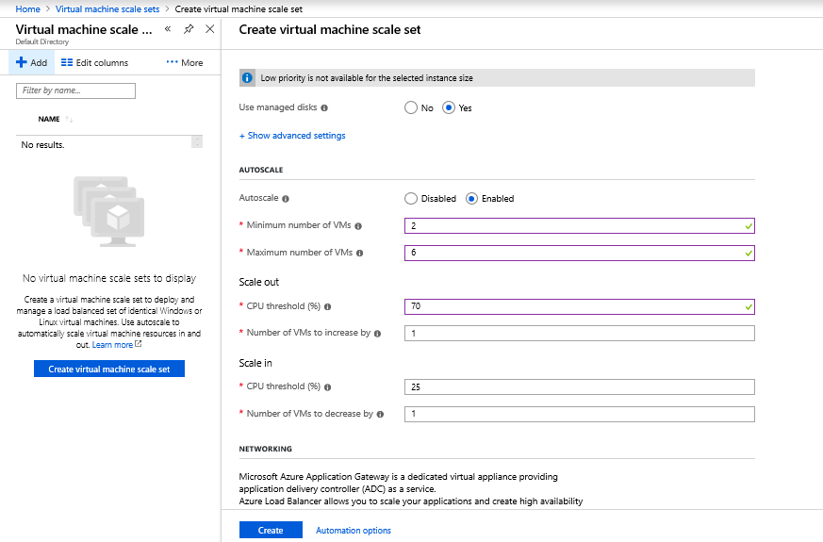

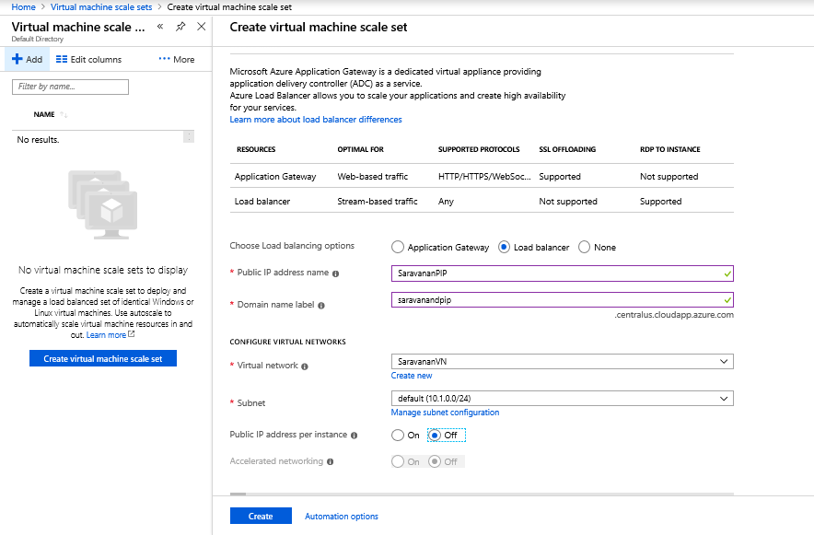

* Steps to Create Recovery Service Vault.

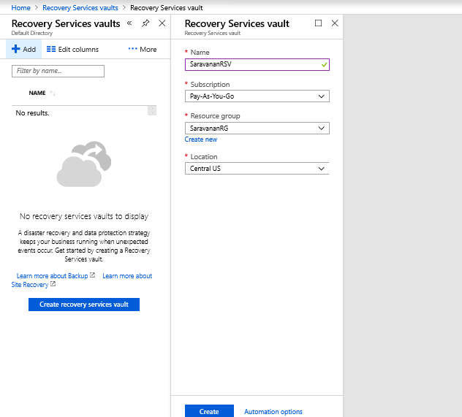

* Backup Policies->Add->Create Backup Policy.

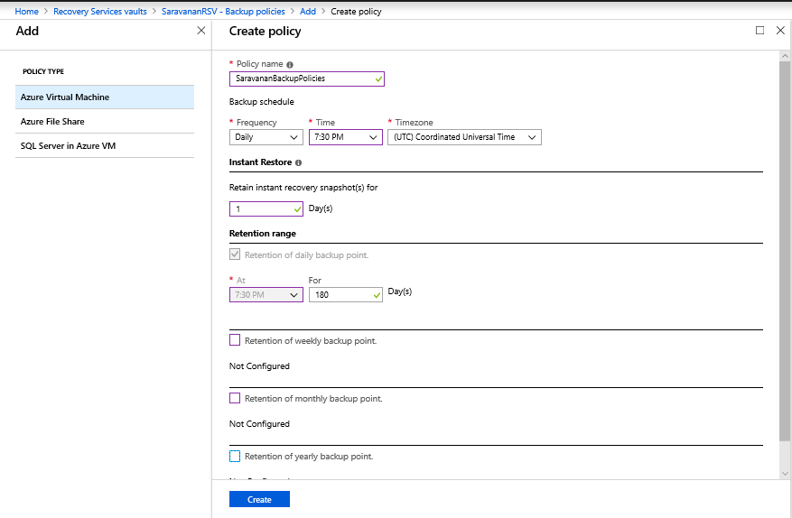

* Adding/applied Policy to Recovery service Vault

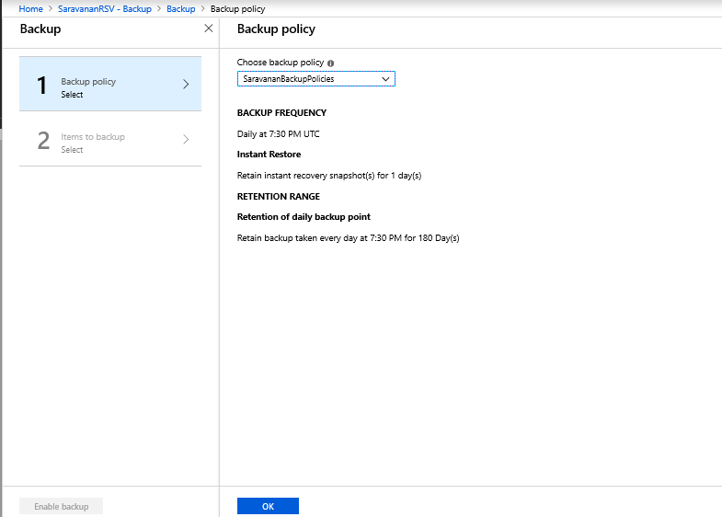

* Selected Virtual Machine for backup.

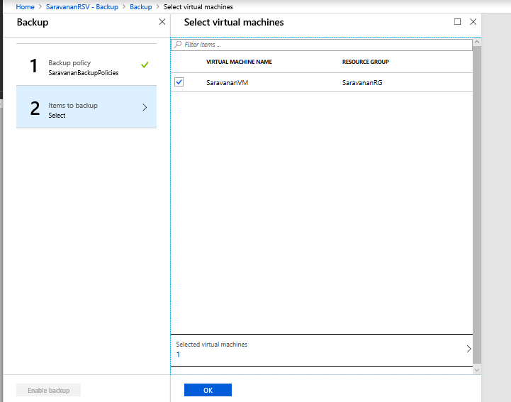

* Select Enable Backup

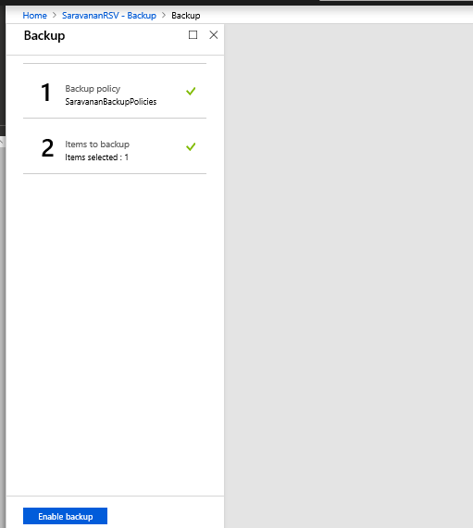

**Steps to Traffic manager of type Performance, priority, weighted.**

* Created Traffic Manager with Routing Method=Performance

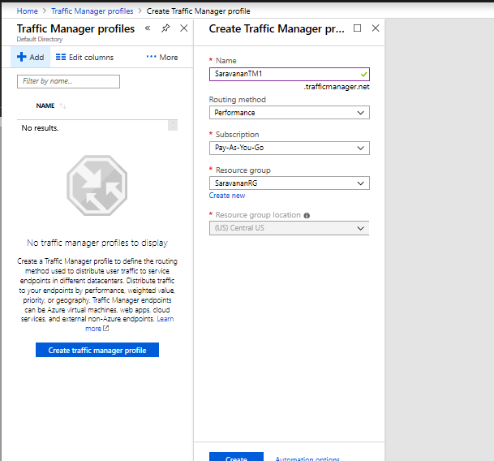

* Added endpoint in Performance Traffic manager.

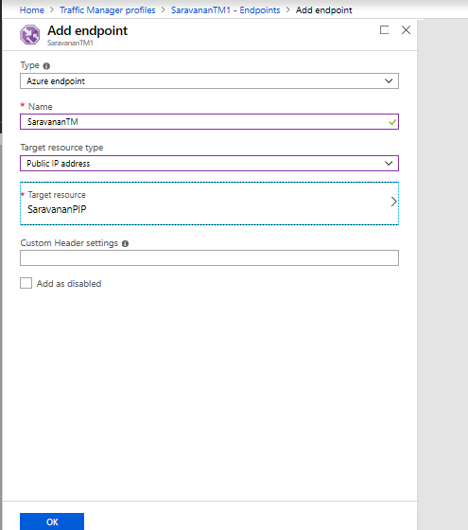

* Created Traffic Manager with Routing Method=Priority.

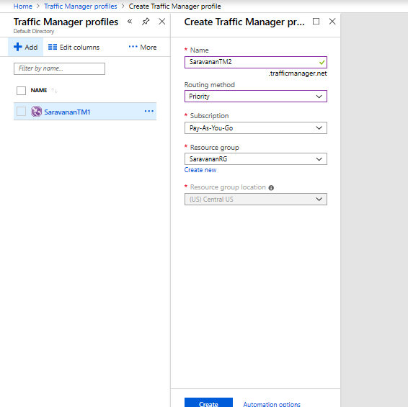

* Added endpoint in Priority Traffic manager.

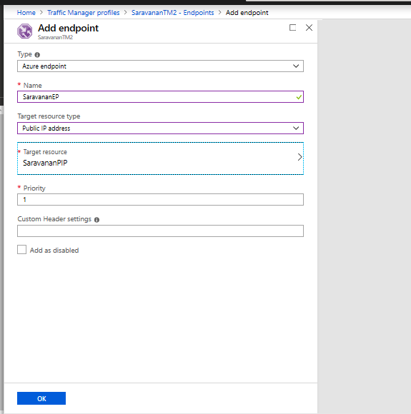

* Created Traffic Manager with Routing Method=Weighted.

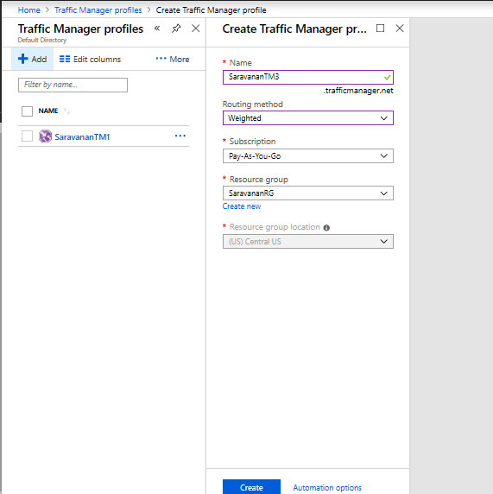

* Added endpoint in Weighted Traffic manager.

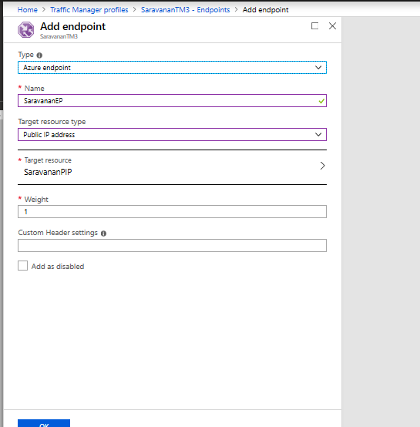

**Steps for Encryption of VM Disk.**

* Goto Active Directory->Application Registories->Create App Registry.

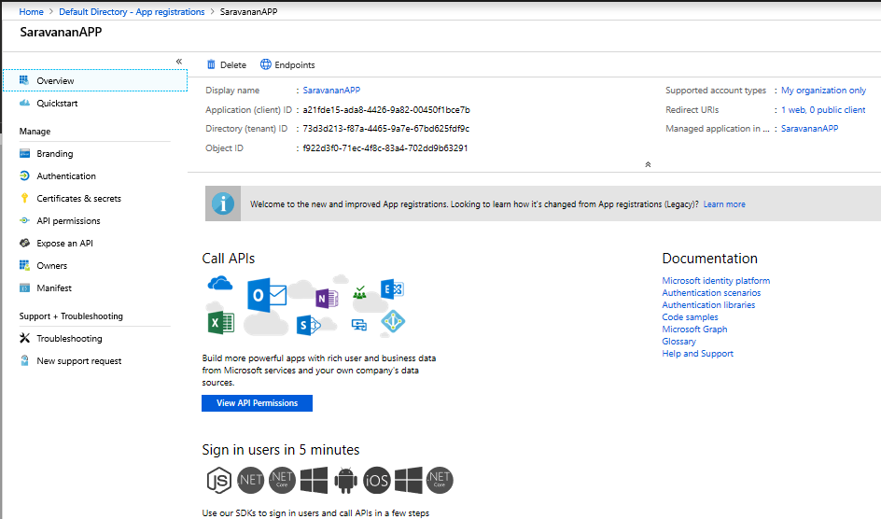

* Create Key Vault.

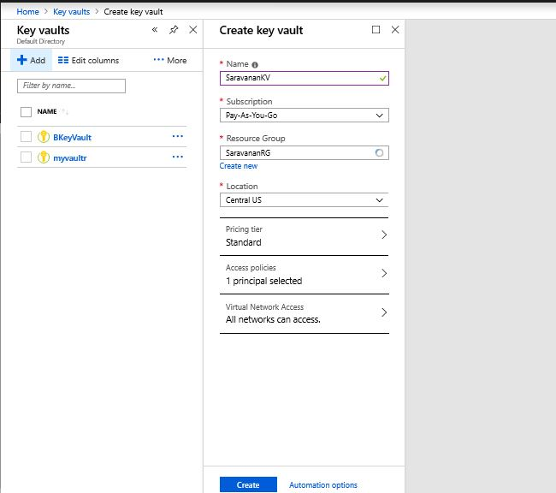

* Goto Key Vault->Access Policies->Add Access Policy.

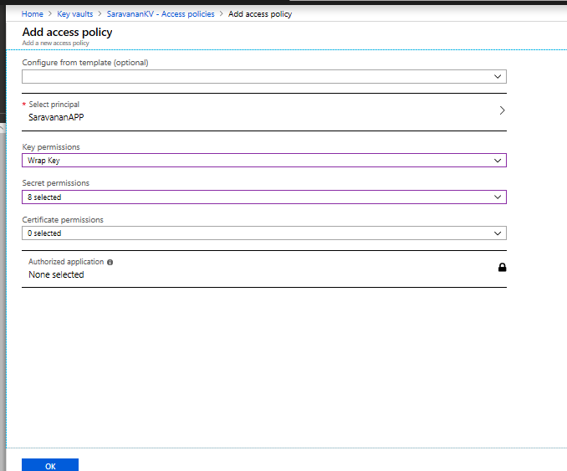

* Goto Azure Active Directory->Application Registories->Settings->Keys, fill Description, expiries->Save.

Key will be generated, copy the key and save it.

**Note**: Key cannot be displayed once you leave the below page.

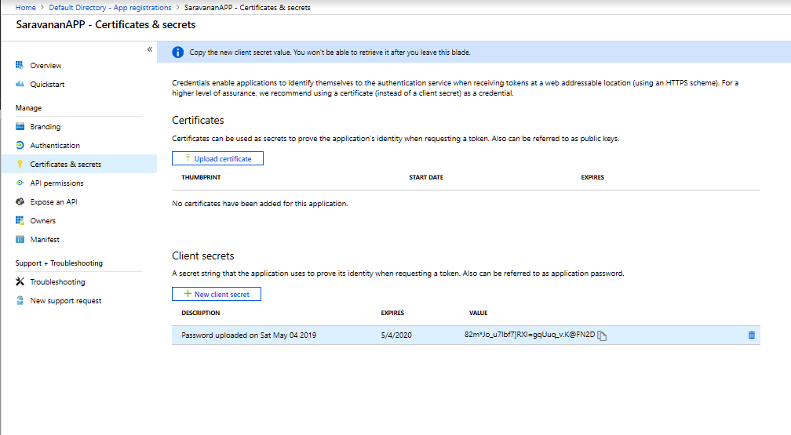

* Create a VM for the Encryption

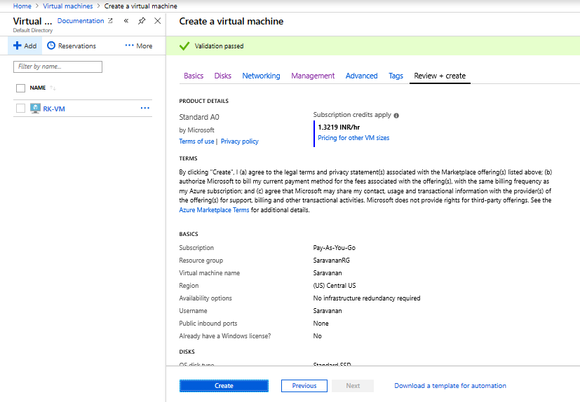

* Goto browser and search “201-encrypt-running-windows-vm” or below link.

<https://github.com/Azure/azure-quickstart-templates/tree/master/201-encrypt-running-windows-vm> then Click on Deploy to Azure, then the below for will be displayed. Fill the form->click on T&C check box->Purchase.

